**Lake City Prosthodontics**

Polly S. Ma, DMD, MSD, Certificate in Prosthdontics

3327 NE 125th Street, Suite 102 • Seattle, WA 98125

(206) 362-8314 • Fax (206) 362-3028

Date_________________

Introducing________________________________________PH#____________________

Referred by Dr._____________________________________________________________

Appointment Date & Time_________________________________________________

Consultation for

□ Comprehensive / □ Limited examination and treatment

□ Fixed prosthodontics (crowns/bridges)

□ Removable prosthodontics (dentures)

□ Implant prosthodontics

□ Full mouth rehabilitation

Radiographs available

□ Yes □ No

□ FM Series □ Pano □ BW □ PA

Comments_______________________________________________________________________________________________________________________________________________________________________________________________________________________________________________________________________________________________________________________________________________________________________________________________

Please fax referral to (206) 362-3028

[frontdesk@lakecitypros.com](mailto:Katie@lakecitypros.com)

www.lakecitypros.com

Information for patients

* Please call us at 206.362.8314 to schedule an appointment
* Please bring along any recent x-rays or have your dentist send them in advance of your appointment

Map

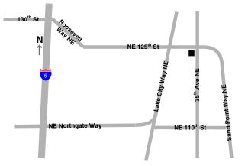

* 3327 NE 125th Street, Suite 102 • Seattle, WA 98125

We are located at SW corner of the intersection of NE 125th St. and 35th Ave. NE

Parking entrance is on NE 125th St.